|  |
| --- |
| About Backing Up Your Data and Settings |
| You can use the new File History feature in Windows 8 or the Folder Redirection Service to back up your data. This guide provides information on how to set up and use each data backup method. This guide also discusses Microsoft User Experience Virtualization (UE-V), a service that you can use to back up your desktop profile and application settings.  Topics in this guide include:   * What Is File History? * What Is Folder Redirection? * What Is UE-V? * Using File History to Back Up Your Data * Using Folder Redirection to Back Up Your Data |

**Customization note:** This document contains guidance and/or step-by-step installation instructions that can be reused, customized, or deleted entirely if they do not apply to your organization’s environment or installation scenarios. The text marked in red indicates either customization guidance or organization-specific variables. All of the red text in this document should either be deleted or replaced prior to distribution.

What Is File History?

File History is a new Windows 8 feature that protects your files by periodically scanning your computer’s file system for changes stored in libraries and in your Desktop, Favorites, and Contacts folders. Whenever you change a file in one of these protected libraries or folders, File History stores a copy on a network drive (managed by IT) that you configure as your backup storage area. Over time, File History builds a complete history of changes. You can quickly find and restore a library, folder, or file from a specific point in time.

File History offers the following advantages:

* It’s very easy to configure and turn on.
* You start out with xx GB of network storage space, although you can request more storage space for business reasons
* It’s very easy to exclude content at any time.
* It provides a good solution for remote users.

What is Folder Redirection?

Folder Redirection redirects the files saved in your local My Documents folder to an IT-managed server. If you choose, you can also back up your Desktop folder, and/or your Favorites/Contacts folders (these two folders are treated as one unit). With Folder Redirection, you don’t need to restore files since the files are stored on a server and “mirrored” back to your computer. Since the files are stored on a server, you can access your data from any computer that you can log on to with your network credentials. For this reason, Folder Redirection is a great solution if you have multiple computers. You can access the latest version of your work anywhere, anytime.

What Is UE-V?

You can use Microsoft User Experience Virtualization (UE-V) to back up your desktop profile and applications settings to your organization’s network. Then if you log in from a different Windows instance, whether it’s a rich desktop or virtual desktop, you don’t have to reconfigure your settings. UE-V automatically delivers a personal experience for Windows 7, Windows 8, Windows Server 2008 R2, and Windows Server 2012 devices, giving you the flexibility to work from anywhere.

Settings backed up by UE-V include:

* Windows desktop personalization settings
* Start menu
* Taskbar
* Folder options
* Internet Explorer® favorites
* Application settings for Office 2010, Notepad, WordPad, and Calculator.

To learn more about UE-V, go to:   
<http://www.microsoft.com/en-us/windows/enterprise/products-and-technologies/virtualization/UE-V.aspx>.

Using File History to Back Up Your Data

*<<Your organization>>* customized File History so that you can automatically configure a managed network drive as part of the turn-on process.

Note

If you are a remote user, you can connect remotely to your corporate network and then configure a network drive as described in this procedure. If the content in your libraries and in your Desktop, Contacts, and Favorites folders is xx GB or under, you will have better performance for the initial synchronization. If the content exceeds xx GB, ITrecommends that you go to a physical office to turn File History on. You can then do subsequent incremental synchronizations over a remote connection.

Configure File History and Turn It On

1. In the **Start** screen, tap or click the **My Data Backup File History** tile.  
   **Customization note:** The following screen capture is for example purposes, you may choose to replace this image with one specific to your organization.

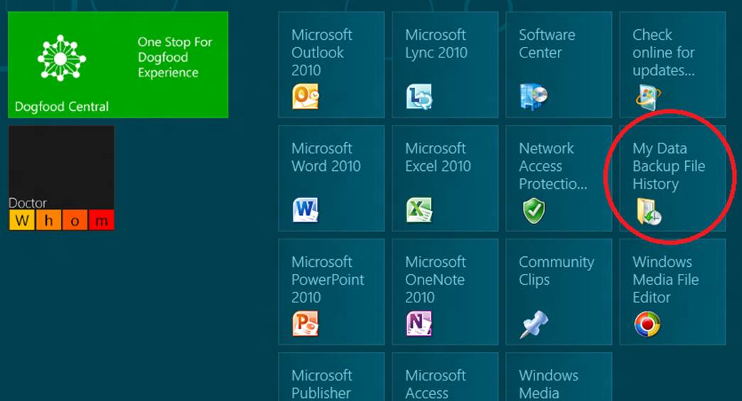

1. In the **File History** dialog box, tap or click the server location closest to you.
2. In the File History (settings) window, tap or click **Turn on**.

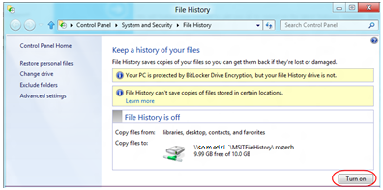

Windows 8 immediately starts backing up your libraries and your Desktop, Contacts, and Favorites folders to a network drive. The network path is displayed next to **Copy files to**.

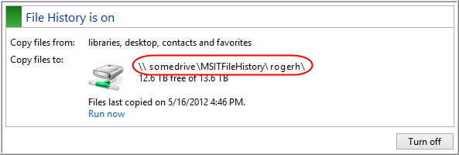

Notes

* If you have more than one computer, you can use this procedure to turn File History on for each computer.
* If you experience any problems backing up your files with File History, contact *<<email>>*.
* For more information on configuring File History, go to <<*file location or URL*>>.

Change File History Settings Using the Control Panel

In the previous procedure, you used the File History (settings) window to turn File History on. You can also use this window to change File History settings. You can open the File History (settings) window through the Control Panel.

To open the File History (settings) window:

1. In the **Start** screen, type **Control Panel**, and then tap or click the Control Panel to open it (or press ENTER).
2. In the Control Panel, under **System and Security**, tap or click **Save backup copies of your files with File History**.

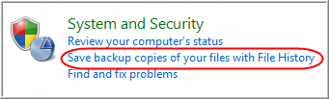

Windows opens the File History (settings) window.

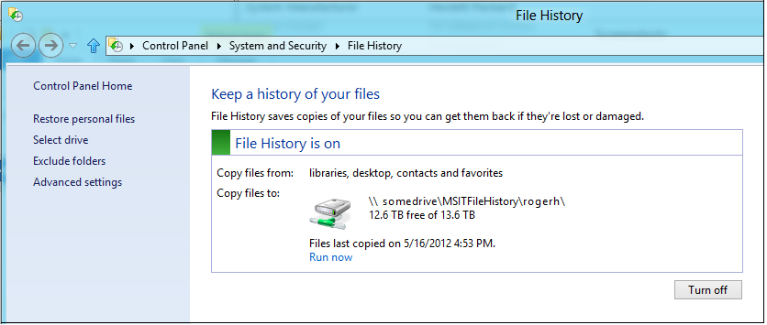

Turn File History Off

1. Open File History in the Control Panel.
2. Tap or click **Turn off**.

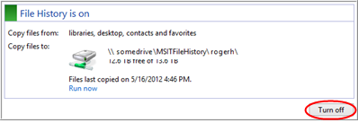

When you turn File History off, your computer retains the configuration information so you can turn File History back on again at any time by tapping or clicking **Turn on** in the File History (settings) window.

Note

If you have more than one computer, you will need to turn File History off for each computer.

Exclude Folders from a File History Backup

By default, File History backs up your libraries and your Desktop, Contacts, and Favorites folders. The storage quota for File History is xx GB, although you can request more storage for business reasons (contact *<<email>>*). As a best practice, clean up obsolete and unnecessary data from your system before backing up. To limit the size of your File History backup, you can exclude folders or even whole libraries. For example, you might want to exclude your Videos library to preserve space.

To exclude folders from a backup:

1. Open File History in the Control Panel.
2. In the File History (settings) window, tap or click **Exclude folders**.

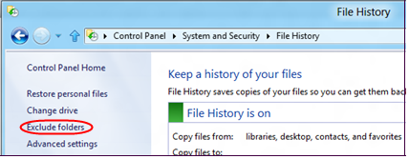

1. In the **Exclude Folders** dialog box, tap or click **Add**.
2. In the **Select Folder** dialog box, select the folders or libraries that you want to exclude from the backup, and then tap or click **Select Folder**.

File History displays the **Exclude Folders** dialog box again and lists the folders or libraries that you chose to exclude.

Add a Folder to Your File History Backup

By default, File History protects all of the folders in your libraries and in your Desktop, Contacts, and Favorites folders. You can protect additional folders by adding them to an existing library or by creating a new library.

To add a folder to a library:

1. In Windows Explorer, press and hold (right-click with the mouse) the folder you want to protect.
2. Tap or click **Include In Library**, and then select the library you want to add the folder to.

The folder will be included in the next backup cycle.

To create a custom library:

* + In Windows Explorer, press and hold **Libraries** (right-click with the mouse), tap or click **New**, and then tap or click **Library**.

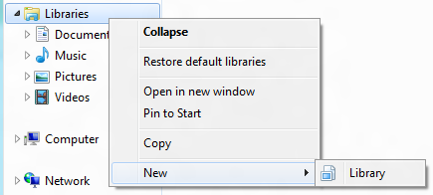

The custom library will be included in the next backup cycle.

Change Backup Settings

By default, Windows backs up changed files every hour. You can use the **Advanced Settings** dialog box to change these settings to back up more or less often. You can also change how long you want to save backed-up files. For example, Windows keeps saved versions forever. You might want to change the **keep saved versions** setting to **Until space is needed**.

You can also use the **Advanced Settings** dialog box to change the size of the offline cache. Windows uses the offline cache to store files locally when the network drive isn’t available (for example, when you’re working remotely without access to the corporate network).

To change backup settings:

1. Open File History in the Control Panel.
2. In the File History (settings) window, tap or click **Advanced settings**.

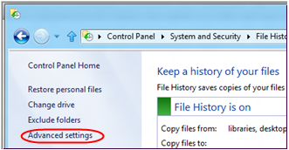

1. In the **Advanced Settings** dialog box, do one of the following:
   * To change how often Windows backs up changed files, in the list next to **Save copies of files**, select a different value from the list.
   * To change the size of the offline cache, in the list next to **Size of offline cache**, select a different value from the list.
   * To change how long Windows keeps saved versions, in the list next to **Keep saved versions**, select a different value from the list.

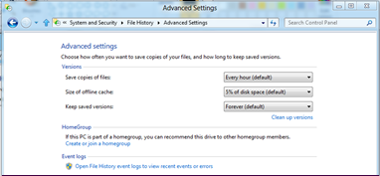

Restore Files

File History saves copies of changed data files in your libraries or in your Desktop, Contacts, and Favorites folders. It’s easy to find and restore libraries, folders, or files from a point in time. To restore libraries, folders, or files:

1. Open File History in the Control Panel.
2. In the File History (settings) window, tap or click **Restore personal files**.

Windows displays the Home – File History window. This window shows all of the folders and libraries that are being protected by File History. The latest point-in-time view of your libraries and folders is displayed.

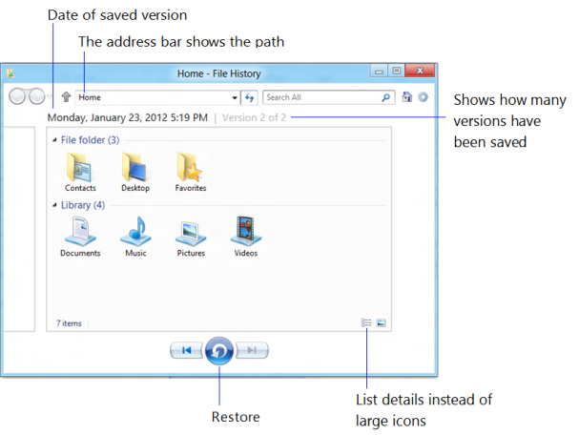

1. To view versions:
2. Find the library, folder, or file that you want to restore, and then double-tap or double-click to select it.
3. Tap or click the **Previous version**  button or **Next version** button to move between versions.
4. When you find the item that you want to restore, tap or click the item, and then click the **Restore to original location** button. If no item is selected, the entire contents of the current version will be restored.

Notes

* As an alternative, you can browse Windows Explorer to find the library or folder that you want to restore, and then tap or click the file to select it. On the ribbon, tap or click the **Home** tab, and then tap or click the  button. This opens the version history for the selected item.
* You can also use the search box in the upper-right corner of the window to search for a specific item. You can search by date or size. Double-click any search result to see versions for that result.
* To get back to the Home screen (top level) of the File History window, tap or click the Home button in the upper-right corner of the window.

Restore All Files

If your computer fails or if you get a new computer, you may want to connect your new computer to the File History backup from your old computer and then restore all files.

1. In the **Start** screen, tap or click the **My Data Backup File History** tile. **Customization note:** The following screen capture is for example purposes, you may choose to replace this image with one specific to your organization.



1. In the **File History** dialog box, tap or click the server location closest to you.
2. In the File History (settings) window, if the new or replacement computer has the same name as the old computer, you’ll see the words **We’ll use your previous File History setup** to the left of the **Turn on** button. You can just click **Turn on** and then skip to step 6 of this procedure.
3. If the new or replacement computer has a different name than the old computer, in the File History (settings) window, select the **I want to use a previous backup on this File History drive** check box. This connects your new computer to the File History backup from your old computer.

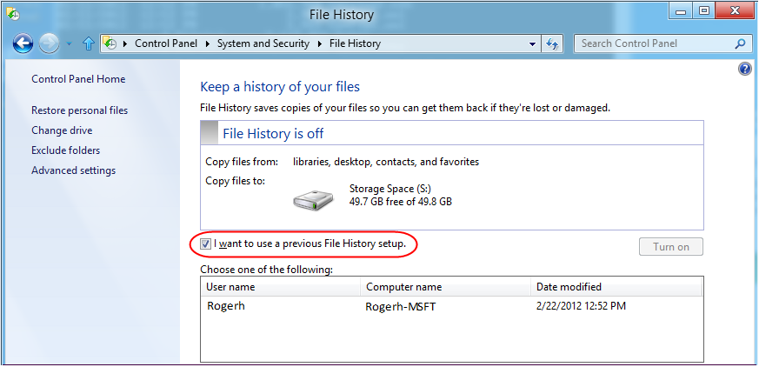

1. Select the appropriate computer from the list.
2. Tap or click **Restore personal files**.

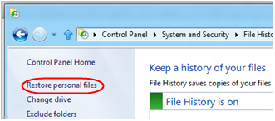

This opens the Home page of the File History (restore) window.

1. On the Home page, select all the folders and libraries.
2. Tap or click the **Restore to original location** button.

All of the selected folders and libraries will be restored to your new or replacement computer.

Using Folder Redirection to Back Up Your Data

Before enrolling in the Folder Redirection service, review the following:

* The Folder Redirection service is governed by privacy and data protection policies. See the Privacy and Data Protection Work Smart Guide for more information:  
   [<<*Work Smart file location or URL*>>.](http://itweb/v7/Work%20Smart/1011_Privacy_and_Data_Protection_WSGFinal.xps?wt.mc_id=1011_Privacy_and_Data_Protection_WSGFinal).
* Encrypted files are not permitted on redirection servers. If you have encrypted files in your My Documents folder, they will not be synchronized with the Redirection server.

Storage Quota

When you sign up for the Folder Redirection service, you receive an initial quota limit of xx GB. If you need more storage for your business requirements, you can request an increase to xx GB, xx GB, or xx GB by sending a request to *<<email>>*. You may be required to answer simple business-justification questions.

Which Files Should I Exclude?

Because your storage is initially limited to xx GB, you may want to exclude folders and directories from your My Documents folder. For example, you might want to exclude rich media files such as Audio Video Interleave (AVI) files, movies, and MP3 files unless there are business reasons to include them. You should also exclude temporary and problem determination files (for example, application and operating-system trace and dump files, such as .tmp and .dmp files) that can be very large but usually do not require protection. As a best practice, it’s a good idea to back up only what you need for business purposes.

Verifying the Size of Your My Documents Folder

Before you start the enrollment process, verify that the total size of your My Documents folder is below the xx GB quota limit. If the total amount of data stored in your My Documents folder exceeds xx GB, the initial synchronization to the server will fail.

The following procedures show how to check the size of your My Documents folders in Windows 7 and Windows 8.

Windows 7

1. Click **Start**, right-click **Documents,** and then click **Properties**.
2. In the **Document Properties** dialog box, next to **Size of files in library**, Windows displays the size of your My Documents folder.

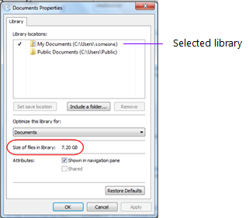

1. If the size is over the allocated quota limit, remove files and then check the size again.

Windows 8

1. In the **Start** screen, tap or click the **Windows Explorer** tile.
2. In Windows Explorer, press and hold **Documents** (with the mouse, right-click **Documents).**
3. Tap or click **Properties**.
4. In the **Document Properties** dialog box, next to **Size of files in library**, Windows displays the size of your My Documents folder.

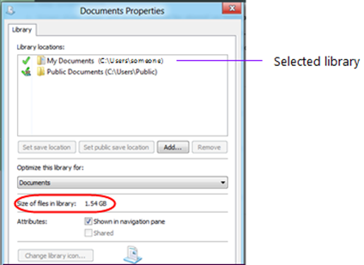

1. If the size is over the allocated quota limit, remove files and then check the size again.

Restore a Previous Version of a File, Folder, or Drive

In most cases, you don’t need to restore files with Folder Redirection because all the files in your My Documents folder (and optionally your Desktop, Contacts, and Favorites folders) are moved to a File Redirection server. The files that are mirrored to your computer are the current versions.

You can use this procedure to restore a version of a file that was saved within the last xx days.

1. In Windows Explorer, find the file, folder, or drive that you want to restore a previous version of.
2. Press and hold (or right-click with the mouse) the file, folder, or drive.  
   A properties dialog box is displayed.

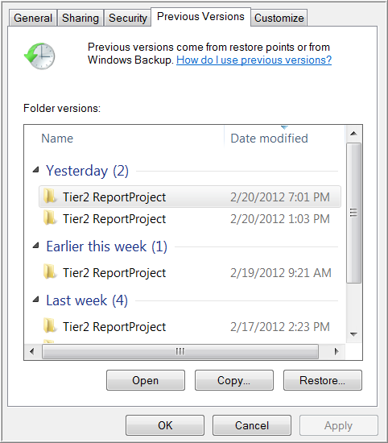

1. Select the version that you want to restore, and then tap or click **Restore**.

Folder Redirection Offline Best Practices

If you disconnect from your corporate network or move from one building to another, it’s a best practice to close or save files stored in the My Documents folder. To learn more about this and other best practices, see << *file location or URL>>*.

Note

To print this Work Smart Guide, press CTRL+P.

For More Information

* **Windows 8**<http://windows.microsoft.com/en-US/windows-8/get-started>
* **Microsoft User Experience Virtualization (UE-V)**   
  [http://www.microsoft.com/en-us/windows/enterprise/products-and-technologies/virtualization/UE-V.aspxl](http://itweb/v7/SecurityStandards/InfoSec_1_General.xps?SourceURL=http://itweb/Security/Policy/General)